Organisms of Steeple Woods

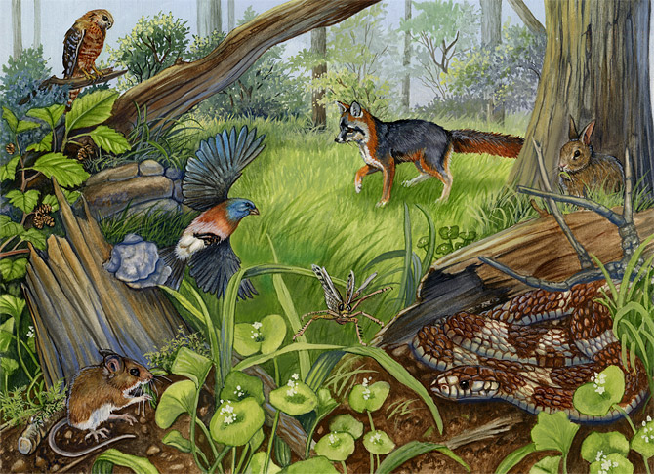

These resources will concentrate on woodland organisms and their predator and prey relationships. One animal kingdom that will be focused on in this session is bird species as they represent the predators in a woodland environment. One session may already have covered invertebrates in woodlands and this session follows up from that one in order to show interaction between different species. The resources in this part of the pack allow students to identify bird species in a woodland environment. Some woodland birds are not on the list because of the small size of the location and many woodland birds prefer large areas of woodland. While doing the session, a problem may occur that no birds may be sighted in the 30 minutes. There are extra notes if this problem does occur that will allow students to answer the hypotheses in the included PowerPoint presentation for this session.

Resources included:

- Woodland Bird Identification Keys
- PowerPoint Presentation which includes the hypotheses
- Lesson Plan of Session

These Activities include:
- Large Group Activities
- Short Pieces of Individual Work
Activities:
- Students will go to Steeple Woods to look for Bird life for 30 minutes.
- After the first activity is over, students will produce a write up explaining their presence in woodland environments.

ALTERNATE RESOURCE
If no birds are sighted then use the following information to answer the question in the presentation. This will give students an idea of different woodland organisms and their predator and prey relationships.

Hypothesis: There are more birds on the trees than on the ground.

- Majority of the bird species stay up in the canopy of the woodland to look for food and avoid predators.
- Some of these predators are mammals - these cannot climb trees or have difficulty doing it.
- Other predators could be other birds of prey - the birds under threat need the height advantage to see the predator bird species coming.
- Birds also stay on the tree as they feed on the invertebrates that live in the bark of the tree.
- Birds that are prey are small and need to be to avoid detection by predators and escape easily through the cluttered woodland environment. Examples Blue Tit, Great Tit, Goldcrest and Wren.
- Some birds are coloured brown or green to become camouflage.
- Predators like the Sparrowhawk need to be high up to spot prey on the woodland floor and the branches of trees.

WOODLAND BIRD IDENTIFICATION KEY
Birds those are likely to be sighted at Steeple Woods.
Small Birds

Large Birds

