Steeple Woodland Nature Reserve
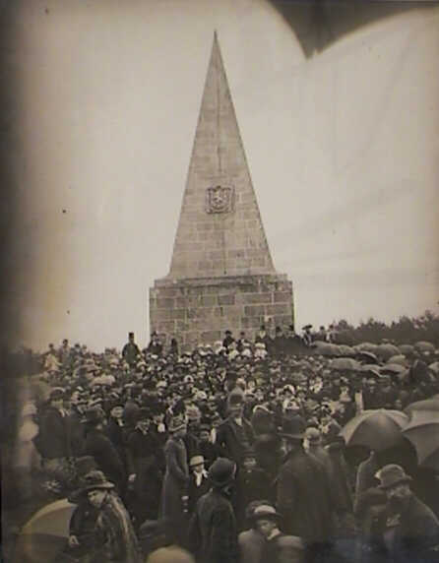
Educational Resource
Pack
For St. Ives Primary Schools

Contents
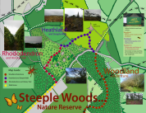
- Map and Nature trail

- 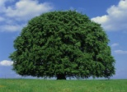 Woodland trail

- 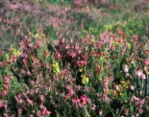 Heathland and Orienteering activities at the Steeple Monument

- 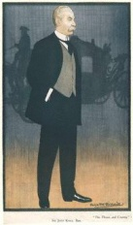 The John Knill song

- 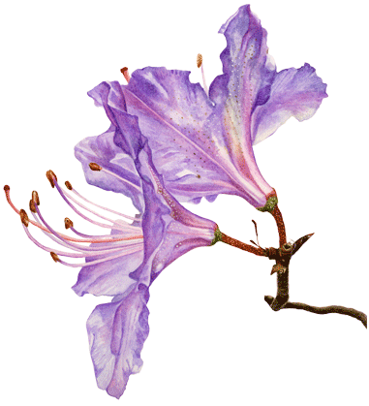 History and effects of Rhododendron on the hill

- Map and Nature trail

This section is the start of your day, commencing with a nature trail around the site. You will need the map and nature trail card given out to the pupils. The rest is self explanatory. There is also a Powerpoint presentation to show before commencing on your day, this is the file called “Nature trail Powerpoint presentation”. The Steeple Woods Nature trail card, OS map and Nature maps are also available as part of this resource pack.

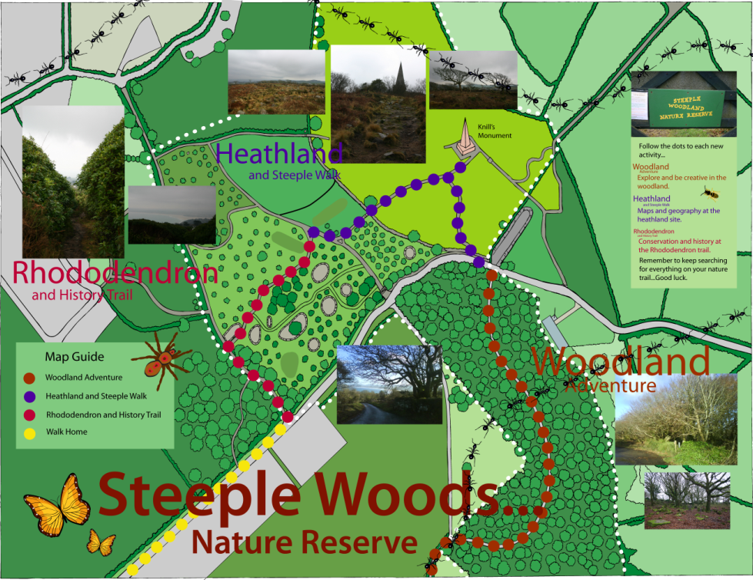

- Woodland Trail - Lesson Plan

1) Arrive at wood. Walk approximately 50 metres in, into a clearing/glade. If it is dry have children seated, if not, stand. Two options displayed in figures 1 and 2.
2) Brief explanation of woodland management history i.e. coppicing and pollarding.
3) Explain to the children the plans for this session:
- To create a collage from anything natural they can find in a given radius (e.g. 50m) with a woodland theme e.g. a tree, insect or fox etc.
- To pick leaves, either from the ground or off branches, place a piece of paper over the top and rub a crayon over the entirety of the leaf’s area – this will create a print which in turn can be cross referenced with the leaf ID, from the Woodlands Trust, to discover which species it is.

4) Move on to the next exercise; could note bat boxes (purpose), mines (copper history) and blown over tree (why it is toppled and then which way the wind must have been blowing?) on the way.
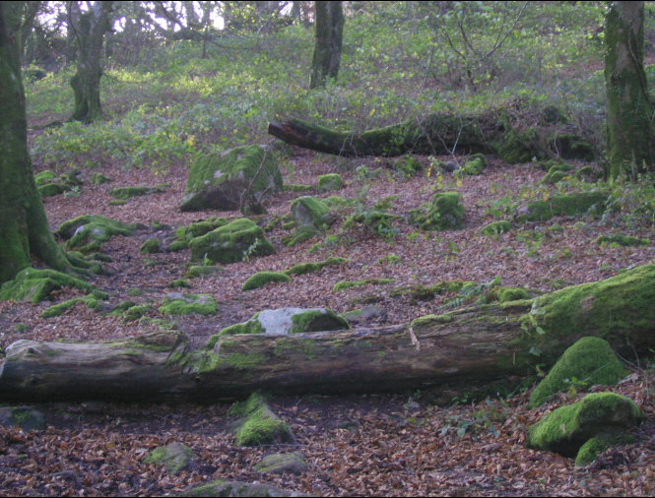
Figure 1 – Seating area for lesson.

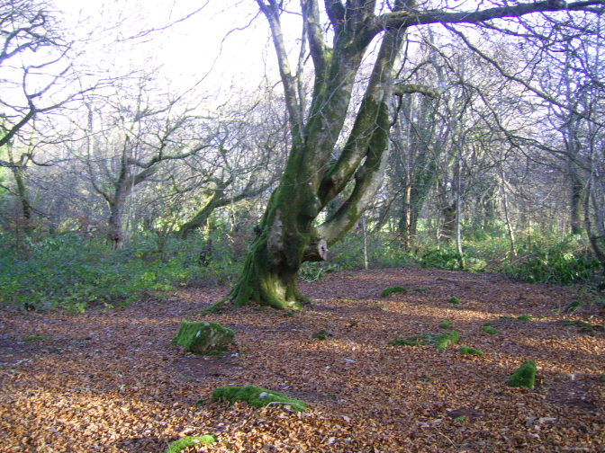
Figure 2 – Alternative glade for lesson to take place.

Teacher’s Notes
Coppicing and pollarding involve cutting trees back to a stump in order to encourage them to sprout new vigorous shoots. This done to maximise the quantity and variety of wood products that could be yielded over time, as it stimulates the tree to grow. New shoots were left to grow until particular products such as poles were ready to harvest – these stems would then be cut and the whole process was started again.
Pollarding was done higher on the tree, typically 6 ft, to also allow animals to graze in the woodland, without being able to reach the new tree shoots. Many old coppiced and pollarded trees are scattered through the wood – when the coppicing/pollarding stopped happening, the trees grew mature branches again – mature trees with several branches growing from just above ground level were once coppiced, those with several branches arising at about head height are old pollards.
The collage is part of the art curriculum, it will develop creative skills and, if done in groups, teamwork and cooperation. There are several options as to how the collage can be composed.
Firstly, pupils could be given individual A4 or A3 pieces of paper with and adhesive side – leaves and twigs etc. could then be stuck upon the paper; the only problems with this technique are cost of adhesive paper and lack of team exercise.
Secondly, groups – of between three and five could work together on collages on A3 adhesive paper.
Finally, groups – of the same numbers – could make their collage on the floor. A space could be cleared on the ground and then the collage created on top. The only problem with this is that ideally no physical matter is taken back to the school but this could be overcome by photographing the artworks and printing them for display later; this may be cheaper than buying adhesive paper and more practical than carrying the collages back. Which technique is used for this exercise should be decided with the teacher’s knowledge of the class to optimise the students’ experience.

The leaf identification falls under the science curriculum. For the leaf identification it should be explained that a variety of tree leaves are needed and not too many leaves from one tree are to be taken – so spread out. There are oak, beech, sycamore, ash and sweet chestnut present, children could be encouraged towards certain trees to diversify the samples; failing that teachers and parents could take some to ensure every species is covered.
Once the leaves have been gathered place the paper on top and crayon over. Then refer to the leaf ID provided to find out the corresponding species. The leaf ID was obtained from the Woodlands Trust website, where more learning materials are available.
A Leaf ID sheet can be found as a word document on the USB stick. On version has just the leaf photos, the other includes the tree names.

- Heathland and Orienteering activities at the Steeple Monument
This document describes a number of activities that can be undertaken with Keystage 1 children when visiting the ‘Steeple Woodlands Nature Trail’. This section provides activities focused on Heathland and what can be seen from the Steeple Monument. It is part of a resource pack for St Ives Primary School on the Steeple Woodlands. It was developed by students of Duchy College, on their Conservation and Countryside Management course, for the module ‘Environmental Education’.
This section focuses on the following:
Heathland activities:
- What is heathland?
- Can you find these heathland plants?
- Story telling: Man in the moon / Sam’s Sad Day

Orienteering activities at Steeple Monument:
- What do you see? What landmarks do you recognise?
- Different (textures of) landscapes
- North/South/West/East: compass
- Looking at maps

Each activity is briefly described, and identifies what materials are to be used. A separate Powerpoint document shows the materials that support the activities. This will provided on this USB stick as
For each activity, the link with the National Curriculum has been explained.
All activities (except number 3. Story telling), are best carried out in smaller groups of say 4-6 pupils. Depending on the number of groups in the class,

these materials need to be duplicated. Below is a summary of a list of materials that will be required for the activities:
- Laminated sheet of ‘What is heathland?’ (1 for each group)
- Laminated sheets ‘Can you name this plant?’ (Choose 2 for each group)
- 2 Stories (1 copy of each per class)
- Ordinance survey maps (1 for each group)
- Copies of Nature Trail Map (1 for each group)
- Compass (1 for each group)

Acknowledgement:
Special thanks go to Jean Snell of Trewidland in Cornwall, who works for ‘Sense of Place’, and is collating a Resource Pack for Key Stage 2 pupils. She provided me with copies of the two stories: ‘The Man in the Moon’ and ‘Sam’s Sad Day’.

1. What is heathland?
Activity:
Show (laminated) card to each group of pupils and ask them how to describe the different pictures:
- Coast / sea / beach / dunes
- Fields / grass / grassland / stone walls / boundaries
- Wood / trees / flowers / bluebells
- Heathland / pink heather

Materials required:
- One laminated sheet per group of children titled ‘ What is heathland’ with pictures
National Curriculum: Key stage 1:
Programme of study: Science
Sc2 Life processes and living things
  - Living things in their environment (a & b )

Programme of study: Geography
3 Knowledge and understanding of places (a)
2. Can you find these plants?
Activity:
Split the pupils into small groups, and give them 2 cards, each with a particular species. (depending on the season, you may only want to use species that are flowering or at least clearly visible). Ask them to look whether they can find them. They have 5 minutes, then get them back as a group.
Materials required:
Laminated sheets titled ‘Can you find these species’
•Heather
•Gorse
•Bracken or Fern
•Blackberry or Bramble
•Violet
•Fox glove
•Tormentil

National Curriculum: Key stage 1: Programme of study: Science
Sc2 Life processes and living things
Living things in their environment (a&b)
Some background information on heathland that may be interesting for the children:
Did you know that….
- Heather; It was used locally for thatching roofs and a source of fuel. Vikings use the flowers to brew beer.
- Gorse; Gorse was used to make a broom to sweep the floor, and gorse bushes were used to dry clothes on. Vikings brewed beer from the flower tops
- Bracken; was used for animal bedding and for thatching roofs
- Foxglove is used in medicines and to make heart drugs. The plant is very poisonous (and can cause rashes, headaches and nausea, if touched without wearing gloves). Floxgloves grown around your house were said to protect from bad influences and disease….

- The John Knill song
When you arrive at the monument after doing the heathland and orienteering section of day there’s an opportunity to sing the “ Old John Knill” song. The song is based around the Flora dance tune, which is played at Helston Flora Day every year.
Music is a great way for young children to remember information. The tune is of course open to interpretation and should be enjoyed by all, including you teachers. The words can be modified as desired by teaching staff.
You could also ask the pupils to make up their own verse based on their visit to the site and/or the stories they about John Knill. They could then add these verses when they sing the song in class.
You will find the lyrics below and an MP3 copy of the tune on the USB stick.
A little history of John Knill
John Knill was born in Cornwall, in Callington on 1st January 1733. His job as an articled clerk to a solicitor in Penzance meant he was well able to deal with all the problems surrounding harbour dues and customs monies. Life was very harsh in 18th century Cornwall and smuggling was rife and the ships that were wrecked on the rocks on this notorious coastline plundered. John Knill knew about many of his neighbours’ activities. He became a Collector of Customs at St. Ives from 1762-1782 and also Mayor of the town in 1767 at 34 years of age. He was a well respected citizen and travelled a lot in a time of roads little more that cart tracks and where all communication was poor. In his position as Customs Officer both in St. Ives and London his advice was eagerly sought and he inspected Custom Houses as far away as Jamaica. He also became a magistrate, was called to The Bar and was Treasurer to the Bench of the Inn. He appeared to enjoy life to the full and socially he met many eminent people, including John Wesley and the engineer John Smeaton. There is a story that John had his mausoleum built high on a hill as a landmark to those at sea smuggling in goods to St. Ives and that he himself was a

smuggler. However, there is no evidence that this is so and could be gossip spread around by his enemies.
Old John Knill
There was a man who bought a hill
A Cornishman known as John Knill
Upon the top a spire he made
In which his body would be laid

Cornishman, through and through
Customs man and lawyer too
Who in seventeen eighty two
Built a grave he would never use

A steeple tall on Worvas Hill
Every five years folk come still
Ten daughters all in white do thrill
And dance upon old John Knill’s Hill

Cornishman, through and through
Customs man and lawyer too
Who in seventeen eighty two
Built a grave he would never use

Tinners and fishermen
Maidens, widows all attend
When July comes to an end
Wear your bonnet and find a friend

Cornishman, through and through
Customs man and lawyer too
Who in seventeen eighty two
Built a grave he would never use

- History and effects of Rhododendron on the hill

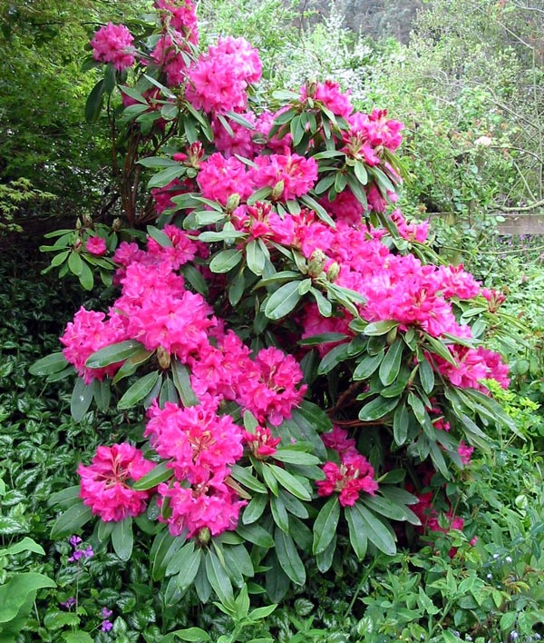
Although magnificent, Rhododendron ponticum is as a nuisance it is very invasive. This plant can be found in woodlands where it has escaped from parks and country gardens.
There is evidence that a chemical is produced by the plant inhibits the germination and growth of other plants .The Rhododendron is host to the sudden oak death fungus, which is now posing a serious threat to trees and other plants in the UK.

The leaves of this plant are poisonous to animals so no animals feed on this plant, however insects such as bees visit the rhododendron flowers. But they do not use the leaves as a food plant it will provide cover for birds too.
Rhododendron ponticum can reproduce by seed, or by roots growing on branches that reach the soil (“layering”).
It takes a great deal of work to kill this plant – cutting and poisoning it using chemicals. You will see that Rhododendron still grows around part of the Steeple site, but that there are many areas where it has been cleared to encourage native plants and animals to thrive.
Rhododendron needs monitoring and strict control to stop it spreading in our countryside.
In summary a beautiful but poisonous and invasive plant.

This environmental educational pack was produced by four Foundation Degree students of Conservation and Countryside Management at Duchy College, Rosewarne in 2009

